Hadoop Word Count Using MapReduce

1. Objective
To create a text file, store it in HDFS, execute the Word Count MapReduce program using Hadoop, and view the word frequency results.

2. Procedure

Step 1: Create a New Text File
cat > tech.txt << 'EOF'
Artificial Intelligence is transforming industries across the world.
Machine Learning enables computers to learn from data.
Big Data technologies help organizations process massive datasets.
Hadoop provides distributed storage and processing capabilities.
Spark enables fast data analytics and machine learning workflows.
EOF

Step 2: Verify the File Contents
cat tech.txt

Step 3: Upload the File to HDFS
hdfs dfs -put tech.txt /demo

Step 4: Execute the Word Count Program
hadoop jar $HADOOP_HOME/share/hadoop/mapreduce/hadoop-mapreduce-examples-*.jar wordcount /demo /output

Step 5: Check the Output Directory
hdfs dfs -ls /output

Step 6: View the Word Count Results
hdfs dfs -cat /output/part-r-00000

3. Source Code

Input File (tech.txt)
Artificial Intelligence is transforming industries across the world.
Machine Learning enables computers to learn from data.
Big Data technologies help organizations process massive datasets.
Hadoop provides distributed storage and processing capabilities.
Spark enables fast data analytics and machine learning workflows.

Commands Used
cat > tech.txt << 'EOF'
Artificial Intelligence is transforming industries across the world.
Machine Learning enables computers to learn from data.
Big Data technologies help organizations process massive datasets.
Hadoop provides distributed storage and processing capabilities.
Spark enables fast data analytics and machine learning workflows.
EOF

cat tech.txt

hdfs dfs -put tech.txt /demo

hadoop jar $HADOOP_HOME/share/hadoop/mapreduce/hadoop-mapreduce-examples-*.jar wordcount /demo /output

hdfs dfs -ls /output

hdfs dfs -cat /output/part-r-00000

4. Screenshots

Creating the Input File
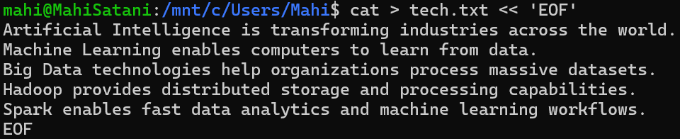

Verifying the File
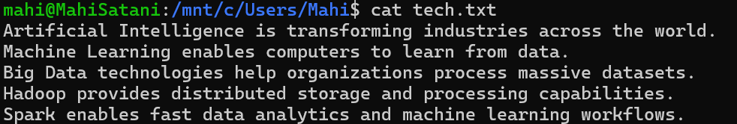

Running Word Count
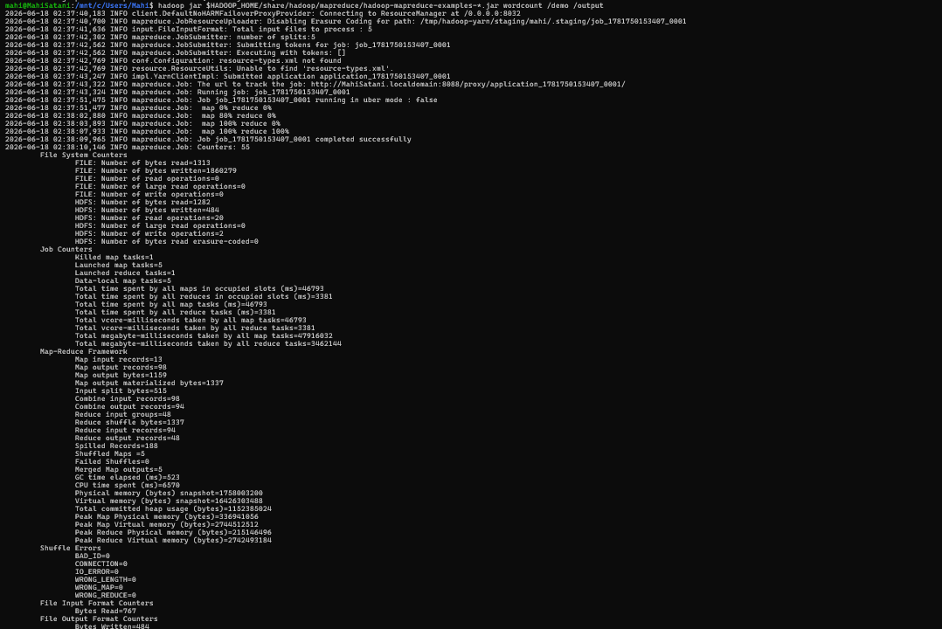

Screenshot 5: Checking Output Directory

Screenshot 6: Viewing Word Count Results
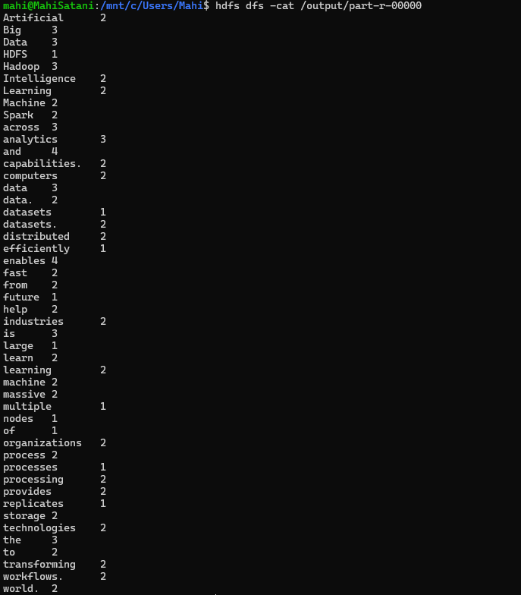

5. Conclusion
The Hadoop MapReduce Word Count application was successfully executed. The input text file was uploaded to HDFS, processed using the built-in Hadoop Word Count program, and the output containing the frequency of each word was generated and stored in the HDFS output directory. This experiment demonstrates the basic working of Hadoop MapReduce for distributed data processing.

